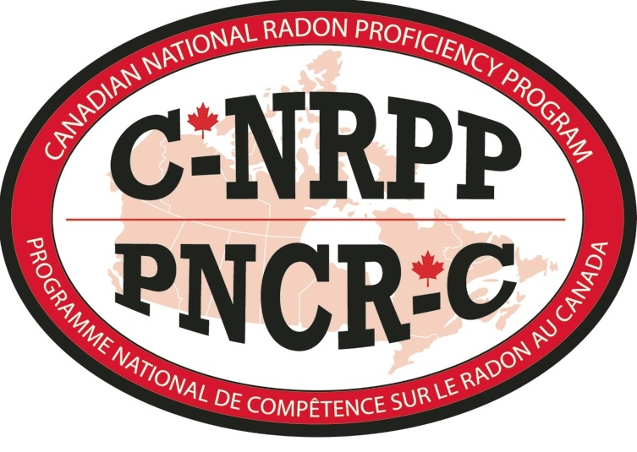
C-NRPP/PNCR-C
4 Donald McClintock Bay
Winnipeg, MB R2G 3N3
Ph:1-855-722-6777
www.c-nrpp.ca email: info@c-nrpp.ca

C-NRPP Renewal Application - Analytical Laboratory Services

COMPANY INFORMATION

(All correspondence will be sent to the main company office address)
Company Name
Address
City |  | Province:
Postal Code
Phone # (one number)
Fax # (one number)
Website
E-mail

List of Measurement Professionals:
Full Name: (list Main Contact First) | C-NRPP Certification #:

List of Devices: Documents Required: (mark X if included)
Renew/Add | C-NRPP Device Code: | Name of Device  (including model # or configurations) | CC | S/PT | Du | B | QA
Required Documents:
As per: C-NRPP Quality Control and Quality Assurance Manual for Radon Sampling and Analysis conducted by Radon Measurement Professionals and Laboratories Dec 2018

CC - Calibration: Proof of manufacturer calibration within the past year must be submitted as well.
S/PT Spike or Device Performance Test: You must also submit proof of having passed a device performance test for each device type listed above. Contact Radiation Safety Institute of Canada, National Laboratories, 1-800-263-5803 (option 4), chamber@radiationsafety.ca, www.radiationsafety.ca, Bowser Morner (in the U.S., 937-236-8805 x 259) to schedule your device performance test.
Du – Duplicate Spreadsheet: You must submit proof of completing duplicate tests on devices for two year period. Spreadsheet must include details on total number of test completed per year and relative percent difference on duplicate tests to verify devices are within acceptable region. Sample templates are available by request from the C-NRPP Office.

B – Blank Spreadsheet: You must submit proof of completing blank tests on devices for a two year period. Spreadsheet must include details on total number of tests completed per year and relative percent difference on blank tests to verify devices are within acceptable region.

QA – Quality Assurance Plan: You must submit a current Quality Assurance Plan. Sample templates are available by request from the C-NRPP Office.

Retain a copy of all forms returned to C-NRPP for renewal. C-NRPP shall not be responsible for the return of any original documents submitted to our office. Send only photocopies of supporting documents with this renewal.

___________________________________________________________
C-NRPP APPLICATION FEE SCHEDULE
Number of Devices | Description | Per Device Fee | Totals
 | A.2 Residential Measurement Analytical Services  + # of device groups _____ x $75 | $ 75.00
 | TOTAL FEE | $
One 8 ½ x 11” certificate is included in the fees.

Please include cheque made payable to “C-NRPP”

If you would like to pay by credit card check here: _________

